WEBINAR on
“Dielectric Test of Switchgears & Transformers”
The objective of this webinar is to keep up with the cutting edge on “Dielectric Test of Switchgears &
Who Can Attend?
Manufacturers, Designers, Electrical Utilities, Consulting Engineers, etc. demicians.
Transformers” as per National & International standards. Some salient features will be focused along with
the cause of failure during testing and service condition.
This Webinar will also provide a platform to exchange technical ideas among participating experts, aiming to share
importance of the Dielectric testing and evaluation as per IS/IEC & IEEE Standard.

CONTENTS
30 January 2026
(Friday)
2:00 PM to 5:00 PM (IST)

- Dielectric test of Instrument, Power & Distribution Transformers.
- Dielectric test of LV & HV Switchgears.

Pre-requisites
You should have good internet connection
and good quality headphone/speaker setup with Laptop / Desktop.

- Failure Analysis With Case Studies

Online Payment Details:
Registration Fee Details
 | Organizations/Institutions | Per person  (Half Day Webinar)
 | State Power Utilities/Government agencies
 | Up to 5 Participants | Rs: 750/-
 | 6 to 10 Participants | Rs:650/-
 | More than 10 Participants | Rs: 600/-
 | Private Sector Organizations
 | Up to 5 Participants | Rs: 1000/-
 | 6 to 10 Participants | Rs:750/-
 | More than 10 Participants | Rs: 600/-
 | Educational Institutions
 | Students | Rs:500/-
 | Faculty members | Rs:500/-
 | Foreign delegates | Rs:1500/-
Note : GST of 18% Extra is Applicable

Last Date of
Registration:
29 January 2026

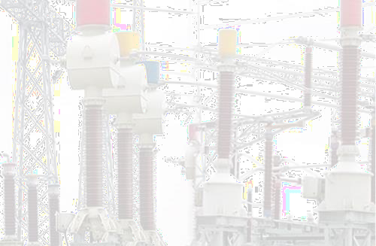
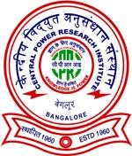
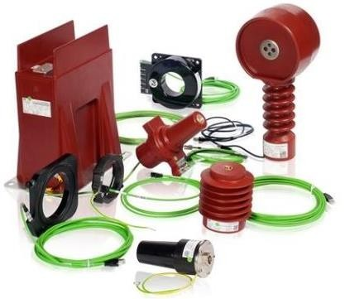

Organized by
Online Payment Portal is available on the CPRI
website http://www.cpri.res.in or by clicking the following link https://cpri.res.in/online- testing/pay_online
Supplementary Test Laboratory (STL)
Note:
- Select “Payment mode against” as Advance Payment/proforma invoice Generated Offline.
- Select Unit as: STDS Bhopal”.
- Select Department as “Supplementary Test Laboratory (STL)”.
- Select Laboratories as “STL-Supplementary Test Laboratory.
If any data or information is unavailable please contact Mr. Sanjaya Kumar Acharya, Accounts officer,
Contact No:9425015954 & 7974045450, 9425602632
Mail ID:acharya@cpri.in
Central Power Research Institute STDS , Bhopal
Co-ordinators
Mrs. Sarita Dongre , Joint Director & HOD (sarita@cpri.in, Mob: 99425602632)
Shri. Rajendra Singh, Engineering Officer Gr-4 &TC
(rsingh@cpri.in,Mob:9425015954)
Mr.Manoj Hirani, Engineering Officer Gr.3 (manojhirani@cpri.in, Mob:7974045450)
Mr. Guguloth Veeranna, Engineering Officer Gr.3 (gveeranna@cpri.in, Mob:9746563852)
Mr. Pratik Kumar Jaiswal, Engineering Officer Gr-2
(pkj@cpri.in, Mob:7278109743

