Webinar on
“Significance and Evaluation of CRGO and CRNGO
Electrical Steels”
28th November 2025
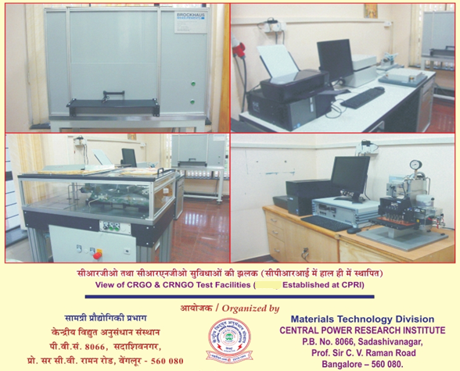

CPRI Profile
Central Power Research Institute, popularly known as CPRI, was set up in 1960 by the Government of India to function as a national organisation for applied research in the power sector and to serve as an independent body for the testing and certification of power equipment. In 1978, it was reorganised as an autonomous society under the Ministry of Power, Government of India. The Head Office and the main setup of the institute are in Bangalore, and its units are located in Bhopal, Hyderabad, Nagpur, Noida, Kolkata, and Guwahati. CPRI laboratories have state-of-the-art research and testing equipment to meet evaluation requirements as per National and International standards. CPRI is a Member of the prestigious STL - Short Circuit Testing Liaison, and the facilities have been accredited in accordance with ISO/IEC 17025 norms. Intertek ASTA, UK and Bureau of Indian Standards also accredit the facilities. CPRI has extensive experience and expertise in material characterisation, simulation, diagnostics, calibration, and system analysis. CPRI also provides consultancy services to meet various needs of the power sector, in addition to offering Customised Training Programmes. It has been extending its services to industries for over six decades in their quest for innovation, new product development, import substitution, quality assurance, etc.

The Materials Technology Division of CPRI is equipped with advanced, sophisticated materials evaluation facilities to provide testing and consultancy services in materials engineering for the power sector. Materials characterisation refers to the use of external techniques to probe the internal structure and properties of a material, which can take the form of actual material testing or analysis. The characterisation of materials such as metals/alloys, ceramics, composites, semiconductors, etc., in respect of their physical, chemical, and mechanical properties is done using sophisticated equipment, keeping their applications in every field in mind.

Significance of CRGO, CRNGO Electrical Steels

Electrical steel, also known as transformer steel, plays a vital role in the generation, transmission & distribution of electrical power. As one of the strategic magnetic materials produced today, these steels are essential in the fabrication of a number of electrical equipment, such as transformers, generators, stators/rotors of electrical motors, etc. They are tailor-made materials with specific physical parameters (e.g., 0.20 to 1.0 mm thick) and metallurgical (e.g., Fe & Si), mechanical (e.g., high ductility), and magnetic properties (e.g., low core loss and high permeability). Produced in the form of cold rolled strips or laminations, they are stacked / wound together to form the core, etc.

Electrical-grade steels are formed by alloying carbon steel with small amounts of silicon, which helps reduce eddy-current losses in the core. The electrical steels follow rigorous metallurgical processes of manufacture and are made by re-rolling standard silicon steel. To get the full advantage from a laminated core, the laminations must be insulated from one another. They are fabricated to stringent surface insulation specifications. Therefore, Electrical steels are available with a wide variety of properties to suit the intended application. The well-known types of electrical steels widely used by the electrical equipment industry are Cold Rolled Grain-Oriented (CRGO) and Cold Rolled Grain Non-Oriented (CRNGO). Prior to their incorporation into the equipment, these steels must undergo rigorous evaluations, followed by certification in accordance with recognised national (typically IS 3024/648/649) and international standards.

Electrical Steels are the basic building blocks for magnetic circuits in rotating machinery and transformer cores. CRGO & CRNGO steels are produced worldwide based on their metallic structure, magnetic properties, and applications. Magnet frames and motor housings are manufactured using precisely punched steel laminations, which are then pressed together in fixture, thus giving them a sturdy structure. Improper processing or handling of these strips, sheets, or long laminations can introduce distortion. These distortions are usually plastic stresses (irreversible) that can alter magnetic properties, thereby impairing the performance of the machines (transformers, motors, etc.) in which they are used.
Workshop Theme / Objectives

Keeping in view the importance of understanding the intricacies involved in the manufacture and evaluation of electrical-grade steels, the Materials Technology Division of CPRI is organising a comprehensive Webinar on the topic “Significance and Evaluation of CRGO & CRNGO Electrical Steels”. This workshop is intended to disseminate knowledge in the field of electrical steel evaluation methods, covering theory, measurement techniques, test procedures, and related aspects. Further, the participants will become conversant with engineering aspects such as the significance of electrical steels in distortion, damage initiation, quality assurance, and their application in electrical equipment, etc.
The topics include, but are not limited to, the following.
- Overview of transformer technology in the country.
- Significance of electrical steels—challenges in the manufacture of Transformers.
- Typical case studies of transformers for benchmarking and failure investigations.
- Characterization methods with respect to magnetic, Insulation and Stacking factor evaluation of various grades of electrical steels
- Gradation (primary and secondary) of electrical steels

Who should attend?

Scientists and Engineers working in the electrical industry, R&D/Academic Institutions, Engineers from the power sector, including State Electricity Boards, Electrical Steel Manufacturers, Prospective users, and Practising Engineers in Thermal & Hydro Power Stations are invited to participate in the workshop.

ORGANISED By :

Dr R. K. Kumar – HoD & Additional Director
Materials Technology Division,
Central Power Research Institute,
Sadashiva Nagar, Bangalore
E-mail : rkkumar@cpri.in
Co-ordinators :
Mr D. Laxman Rao, Engineering Officer / Mr G. Kishore Kumar, Consultant
E-mail : laxman@cpri.in / kishorecpri@gmail.com
Mob : 83052 49090 / 9449025480
********************************

